Application of Improved Prim Algorithm in Unmanned Aerial Vehicle Cruise System
Funa Zhou¹, Po hu^{1,*}
1.School of Computer and Information Engineering, Henan University, Kaifeng, China
2.College of Electrical Engineering, Henan University of Technology, Zhengzhou, China
¹zhoufn2002@163.com, ² @163.com (* Corresponding Author),
Abstract: Unmanned Aerial Vehicle (UAV) is a new type of combat platform with the capability of autonomous flight and independent execution tasks. It can perform tasks such as military reconnaissance, monitoring, search and target pointing. When a UAV is used to perform a reconnaissance task on a specified multi-target point, the optimal cruise route for UAV reconnaissance missions is created to ensure that the cruise time of the UAV is minimal. The track cost model is transformed into the constrained minimum spanning tree problem, and the improved Prim algorithm is used to realize the track planning. Coordinates A(L,B,H)(longitude, latitude, height) in the Geodetic Coordinate System are transformed into coordinate A (X,Y,Z) in the Spatial Cartesian Coordinate system before the cruise path is planned. The weight matrix between the target points is obtained, and the optimal cruise sequence is obtained by using the improved Prim algorithm. Through the GPS module to obtain the coordinates of the aircraft itself, use PID (Proportion Integration Differentiation) algorithm to control the aircraft in accordance with the target point in the order specified cruise. The algorithm is embedded in aircraft. Hence, the aircraft can autonomously plan the flight path and complete the UAV on the specified multi-target point of the cruise task.
Key words: UAV; path optimization; Prim algorithm; coordinate transformation; PID

1 Introduction
With the continuous development of science and technology, UAV applications are becoming more and more, the implementation of reconnaissance mission is an important application of unmanned aerial vehicles. A good cruise route can not only reduce the cost of executing the task, but also reduce the risk of executing the task. Static planning refers to the cruise route has been planned before the aircraft took off, and dynamic programming is the process of cruising in accordance with the need to dynamically modify the course of the road planning [1, 2]. Dynamic programming is based on static programming, so static programming is one of the main contents of this paper.
In the problem of track planning, A-Star search algorithm [3], genetic algorithm [4], dynamic programming [5], dijkstra algorithm [6], particle swarm algorithm [7] and so on are commonly used. The A-Star algorithm determines the next path grid by comparing the heuristic function value F of eight neighbors of the current path grid. The A-Star algorithm can’t guarantee the optimal path when there are multiple minimum values. In the case of improper selection of fitness function, genetic algorithm may converge to local optimum, but can’t achieve global optimization. In this paper, the UAV path optimization algorithm is based on the Prim algorithm, Prim algorithm itself is an algorithm to construct the MST (minimum spanning tree) [8, 9], it constructs the minimum spanning tree (MST) in a point-by-point fashion, it can solution the optimal path problem. In this paper, we propose an improved Prim algorithm for path optimization, which has the same time complexity with Prim algorithm, but simple calculation and easy implementation, the most important thing is its effect is much better than the original algorithm. Through the validation of a large number of experimental data, the solution obtained by the algorithm and the global solution obtained by traversing all the solutions remains the same.
In practice, the most common and easiest to get is the target coordinates data which is showed by latitude and longitude of Geodetic Coordinate System, so the system input data for each specified point in the earth coordinate system coordinates A (L, B, H), also is the coordinates of latitude and longitude, after the data has entered the system, the data of each coordinate point must be converted and converted into the Spatial Cartesian Coordinate system [10] coordinates A (X, Y, Z). From the coordinates of Spatial Cartesian Coordinate system under the coordinates of all points can be obtained the distance weight matrix.
The aircraft flight control is based on the integral separation PID algorithm [11,12]. The accelerometer and the three-axis gyro sensors are used to obtain the acceleration and rotation angular velocity of the vehicle. The elevation angle pitch, roll angle roll and yaw angle yaw are obtained by 3D attitude calculation [13]. The three attitude variables are used as the control variables of the PID algorithm, and the result is output to the actuator of the aircraft, so as to realize the balance control of the aircraft. With the GPS module, the aircraft's own coordinates can be obtained [14], and the aircraft can be controlled by the PID algorithm, which can cruise the target point according to the cruise order after the path planning, finally realize the unmanned aerial vehicle self-planned detection path and finish the investigation task.

2 Prim algorithm
Prim's algorithm is an algorithm to construct the minimum spanning tree of a graph [15-17]. It constructs the minimum spanning tree by connecting vertexes one by one. Primer's basic idea is described as follows:
Starting from a vertex in the connected graph G = (V, {E}), the minimum weight edge (, v) associated with it is selected and its vertices are added to the vertex set U of the spanning tree. Each step is then selected from the edges (u, v) whose vertices are in U and the other vertices are not in U, and the edges are added to the edge set TE of the minimum spanning tree, the other vertices is added to the set U. This is repeated until all the vertices in the network are added to the vertex set U of the spanning tree.
For the undirected connected weighted graph G = (V, {E}) with n vertices, in the resulting spanning tree with n-1 edges and vertices connected to each other, And the smallest tree process, that is, the process of constructing the minimum spanning tree. The process of constructing the minimum spanning tree using Prim algorithm is shown in Fig.1. V1toV6 are the target points, and the number between the two target points is the weight between the two target points. Fig.1. (a) is the connectivity network G, Figures b to f is process to construct the minimum spanning tree. An undirected weighted connected network is shown in Fig.1. (a). From all the nodes in the network, take any one of them as the starting point, find all the points with the smallest weight value connected to V1, and connect the two points, the result as shown in Fig.1. (b). Then find the point with the minimum weight of all the points connected to the two points, connect them, as shown in Figure c, in turn, until the formation of n-1 side, at this time is the formation of the spanning tree , the spanning tree is shown in Fig.1. (b).
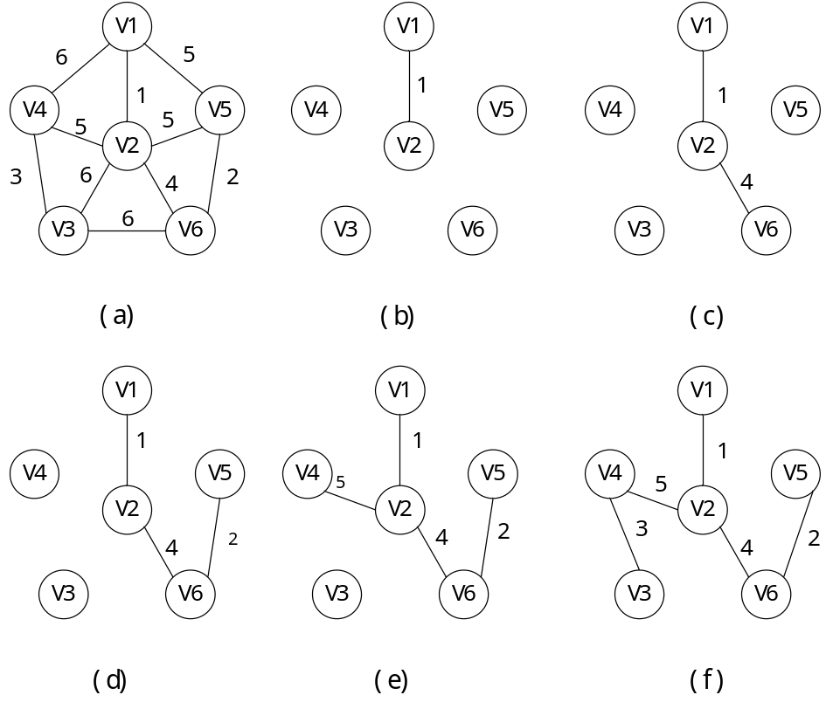
Fig.1. Process of construct the minimum spanning tree by Prim algorithm
The process of constructing the minimum spanning tree using Prim algorithm is shown in Fig.1. A more specific description of the steps to construct the minimum spanning tree is as follows.
Step1: Initialize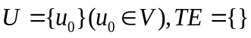.
Step2: for any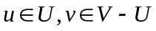constituted edge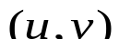, Find an edgewith the least weight for any of the constructed edges, and added to,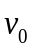will be added to.
Step3: If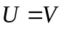, then turn Step4, otherwise go to Step2.
Step4: Therefore, in the spanning tree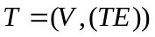, there must be a set of edge-forming 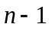edges,is the minimum spanning tree of the connected graph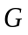.

3 Improved Prim algorithm
There are two aspects that need to be improved to solve the problem of UAV route planning. First, from the Prim algorithm described earlier, the uncertainty of the initial point selection will result in that the spanning tree search using Prim algorithm is not unique. In practice, we want to get the spanning tree which is the only optimal. Therefore, Prim algorithm must be improved to set the necessary search starting point, the search limit conditions and search order. To make the original uncertainty of the process into a certain process, and retain the advantages of Prim algorithm in the same time. Second, although the minimum spanning tree path can be used directly to construct the UAV cruise route, but in reality we hope that the UAV cruise path is a non-reciprocating route. However, the minimum spanning tree is a tree structure, it will inevitably lead to some side of the vertex degree of more than 2, which will form a reciprocating path and an increase of cruising costs. In view of these two aspects of the improvement requirements, the improved algorithm is described as follows.
Step1: Traversing all edges, finding the edge with the smallest weight (,), two vertices and associated with the edge are added to the set of vertices U, U= {,} (, V) ，TE= {(,)}.
Step2: Using the vertex , in the set U = {,} as the search starting point, the minimum spanning tree T is obtained by the Prim algorithm.
Step3: In the minimum spanning tree T, finding the vertices whose degree is greater than 2, then leave the two edges with the smallest weight connected to the point only and delete the remaining edges connected to the point so that the degree of the vertices is 2.
Step4: Find the edge with the smallest weight in the edges connecting all the vertices whose degree is less than 2, and check whether the join of the edge will generate the loop before adding this edge to the set U of the edge found. If a loop is generated in the set, the edge is discarded. Then continue find the next smaller edge in addition to this edge. Otherwise perform the fifth step.
Step5: Add the edge to the set of found edges. If the number of edges is less than n-1 (where n is the number of vertices), proceed to step 4. If the number of edges is equal to n-1, the shortest path planning is completed.
The following 10 target points is an example to illustrate, the coordinates of the target point in the plane Cartesian coordinate system as shown in Table 1.
Table 1 Coordinate of the target point
Point
Coordinate | (42,83) | (85,104) | (96,78) | (73,47) | (52,72)
Point
Coordinate | (69,70) | (40,23) | (105,38) | (55,103) | (70,21)
The weight matrix between any two target points, also distance matrix between the target points, is calculated from the ten points shown in Table 1, as shown in Table 2.
Table 2 Weight matrix between target points
 | 0.00 | 47.85 | 54.23 | 47.51 | 14.87 | 29.97 | 60.03 | 77.42 | 23.85 | 68.03
 | 47.85 | 0.00 | 28.23 | 58.25 | 45.97 | 37.58 | 92.66 | 68.96 | 30.02 | 84.34
 | 54.23 | 28.23 | 0.00 | 38.60 | 44.41 | 28.16 | 78.49 | 41.00 | 48.02 | 62.65
 | 47.51 | 58.25 | 38.60 | 0.00 | 32.65 | 23.35 | 40.80 | 33.24 | 58.82 | 26.17
 | 14.87 | 45.97 | 44.41 | 32.65 | 0.00 | 17.12 | 50.45 | 62.97 | 31.14 | 54.08
 | 29.97 | 37.58 | 28.16 | 23.35 | 17.12 | 0.00 | 55.23 | 48.17 | 35.85 | 49.01
 | 60.03 | 92.66 | 78.49 | 40.80 | 50.45 | 55.23 | 0.00 | 66.71 | 81.39 | 30.07
 | 77.42 | 68.96 | 41.00 | 33.24 | 62.97 | 48.17 | 66.71 | 0.00 | 82.01 | 38.91
 | 23.85 | 30.02 | 48.02 | 58.82 | 31.14 | 35.85 | 81.39 | 82.01 | 0.00 | 83.36
 | 68.03 | 84.34 | 62.65 | 26.17 | 54.08 | 49.01 | 30.07 | 38.91 | 83.36 | 0.00
Those coordinate data of ten target points in Table 1 and the distance matrix data between two target points in Table 2 as an example, the steps to get the optimal solution using improved Prim algorithm are described as follows.
Step 1: Traverse all edges, find the edge with the smallest weight (,), addition,to the set U.
Step 2: Using the set U={,} as the starting point, using Prim algorithm to get the minimum spanning tree as shown in Fig. 2. (a).
Step 3: The points with vertices greater than 2 has , For vertices with degrees greater than 2, each edge retains only the two edges with the least weight, and the remaining edges are deleted. That is, the edges of the spanning tree are deleted(，) (，). The results are shown in Fig. 2. (b).
Step 4: Find the edges with the smallest weight() in the edge formed by any two vertices in all the vertices whose degree is less than 2，，). ()is added to the loop. Since there is no loop, the edge is added to the TE, as shown in Fig.2. (c). And then continue to find the edge of the vertex is less than the minimum edge weight edge (), add it to the edge set TE, the edge of the join did not produce a loop, and the number of edges is equal to n- So the path planning is completed. The optimal path is shown in Fig. 2 (d). That is, the optimal path is 7-10-4-6-5-1-9-2-3-8, and the total path length is 234.68. （the total length of the scheduled path）
To verify the validity of the algorithm, the global optimal solution is 234.68 by Traverse all solutions. The results show that the algorithm is globally optimal. ??
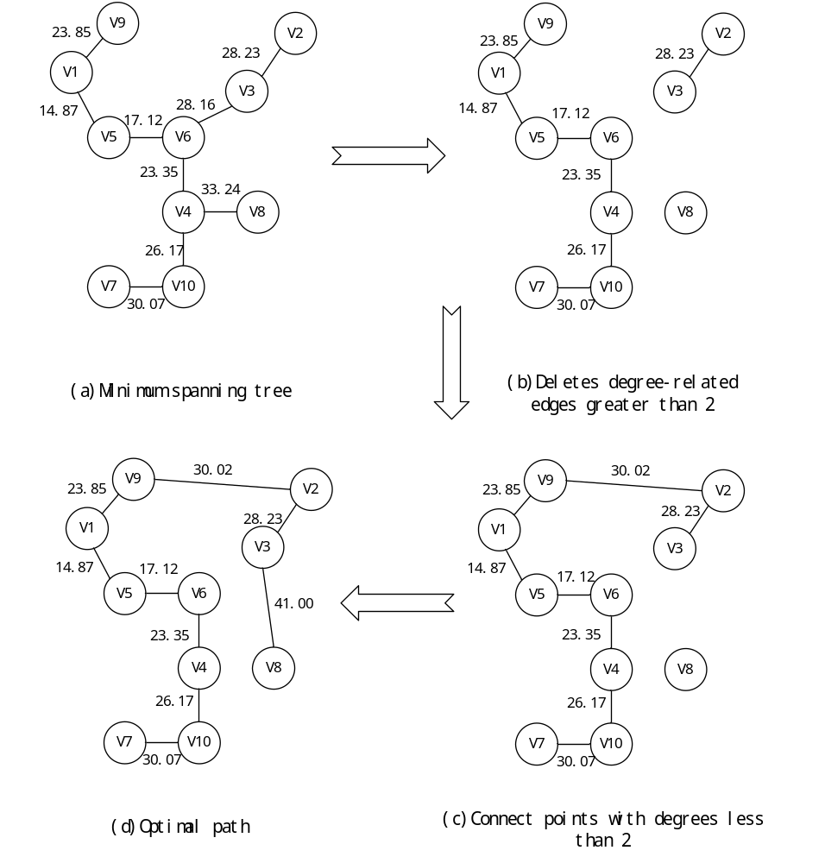 Fig.2. Implementation process of improved Prim algorithm

4 Application of Improved Prim Algorithm in UAV Path Planning

4.1 UAV Experimental Platform Description
In this paper, the experimental platform is four-rotor aircraft. The main controller of this platform is STM32f104 chip as the main controller. The top integrates STM32 minimum system, wireless data transmission module, motor drive circuit, GPS, and so on. In the four-rotor control panel using OLED as human-computer interaction interface, the control panel through the NRF24L01 wireless module data input to the host MCU. Brushless motor as the actuator, the test module used to test whether the aircraft arrived at the designated location. The experimental platform is shown in fig.3. (F大写)
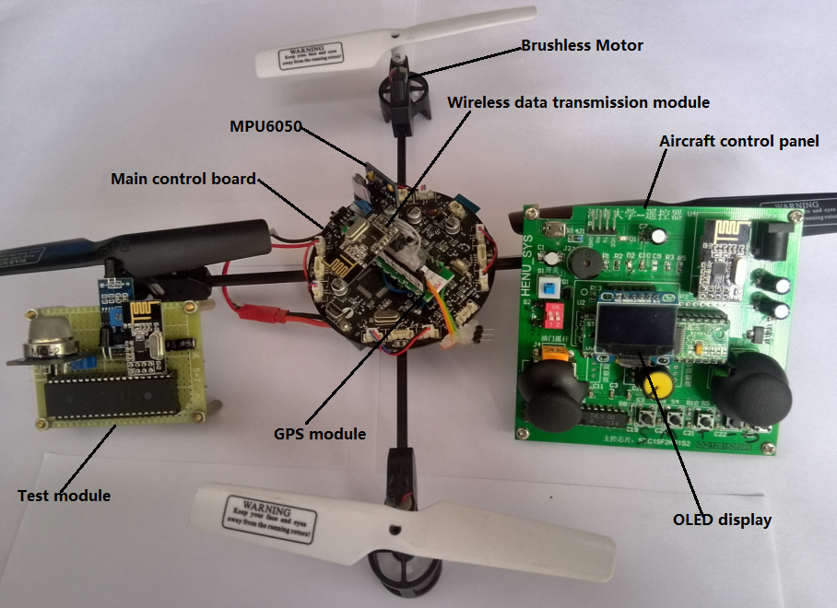
Fig.3. Experimental platform
Coordinate data in the geodetic coordinate system of the pointing target point, that is, the coordinates of the target point to be cruised in the geodetic coordinate system, are inputted to the main controller MCU before the cruise of the unmanned aerial vehicle. First, the coordinates in the geodetic coordinate system are transformed into the coordinates in Spatial Cartesian Coordinate system, and the coordinate points are projected in the two-dimensional plane rectangular coordinate system. Then the coordinate vector of all target points is input to the path optimization algorithm, and the optimal route of UAV cruise is output after the algorithm. Finally, the unmanned aerial vehicle in accordance with the planned route to perform reconnaissance missions.
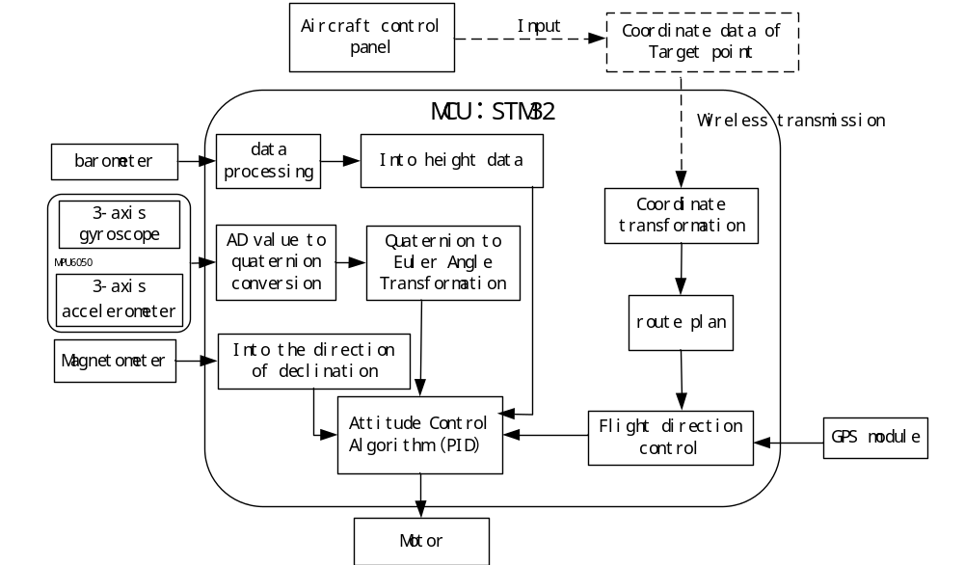
Fig.4. Working block diagram of the aircraft (Flow Chart)
The algorithm given in Section 3 of this paper is given in Cartesian coordinate system. Based on the hardware framework shown in Fig. 3, the author's lab independently developed the experimental platform for unmanned aerial cruise, System block diagram shown in Fig.4. Using the PID control algorithm for UAV attitude stabilization control(PID controller is used for attitude stabilization control of UAV) [18]. through the GPS module (Additional GPS module is equipped on the UAV to )obtain the coordinates of the aircraft itself. To use the improved Prim algorithm as a path planning algorithm for unmanned aerial cruise, it is necessary to convert the geodetic coordinate system into a spatial Cartesian coordinate system.

4.2Transformation of Geodetic Coordinate System and Spatial Cartesian Coordinate system
For each target point that needs to be cruised, the coordinate data in longitude and latitude is the easiest to get. Therefore, before planning the paths, in order to get the coordinates of target points in Spatial Cartesian coordinate system, transforming the coordinates is necessary.
The origin of Spatial Cartesian coordinate system lies in the center of the reference ellipsoid. The Z axis points to the north pole of the reference ellipsoid. The X axis points to the intersection of the starting meridian and the equator. And the Y axis lies on the equatorial plane. According to the right-handed coordinate system, the angle between X and Y axis is 90°.The coordinate of a point in space can be represented by the projection on each coordinate axis of the coordinate system. The Spatial Cartesian coordinate system can be represented by Fig.5.
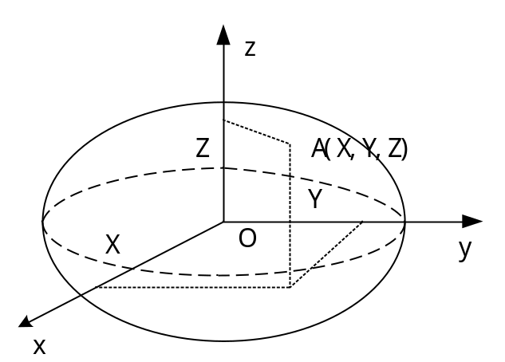
Fig.5. Spatial Cartesian coordinate system
Geodetic Coordinate System is to use latitude and longitude and earth height to describe the spatial location. Latitude is the angle between the point of space and the equatorial plane of the reference ellipsoid; Longitude is the angle among the point in space and the plane of the reference ellipsoid where its rotation axis lies and the starting meridian surface of the reference ellipsoid. The height is the distance along the normal direction of the reference ellipsoid to the surface of the reference ellipsoid. Geodetic Coordinate System can be shown in Fig. 6.
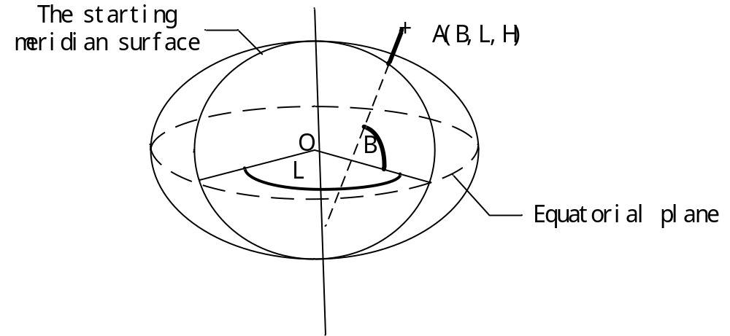
Fig.6. Geodetic Coordinate System
The transformation from the geodetic coordinate system to the Spatial Cartesian coordinate system under the same datum is the formula (1).
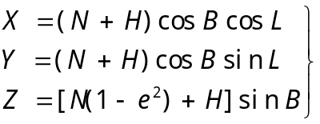 (1)
Among them,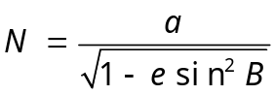, 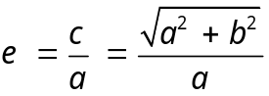.Theas the curvature radius of ellipsoid, is the eccentricity, is the long axis of the ellipsoid, is the short axis of ellipsoid. The national geodetic coordinate system of 2000 shall prevail, where the value shown in Table 3.
Table 3 Value of the parameter
parameter
value | 6378.137km | 6356.7523141km | 0.081819191042811

Taking Henan University as an example, eleven target points are selected in Henan University, and the target points are assumed to be zero from the ground height. By the above formula, the coordinates of Geodetic Coordinate System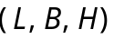 of each target point and the coordinates of the Spatial Cartesian coordinate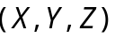 system are obtained. The coordinate transformation results of which are shown in Table 4.
Table 4 Coordinate conversion results
Position | longitude | latitude | X | Y | Z
Zhi Yi stadium | 114.31944 | 34.82488 | -2185.5907 | 4836.1710 | 3667.2371
AS | 114.31912 | 34.82538 | -2185.5515 | 4836.1549 | 3667.2850
7th Building | 114.31911 | 34.82570 | -2185.5424 | 4836.1377 | 3667.3151
Bei yuan | 114.31930 | 34.82701 | -2185.5260 | 4836.0581 | 3667.4384
Life Sciences | 114.31980 | 34.82772 | -2185.5507 | 4835.9996 | 3667.5056
Special Laboratory | 114.31689 | 34.82738 | -2185.3126 | 4836.1294 | 3667.4740
EA | 114.31772 | 34.82595 | -2185.4186 | 4836.1769 | 3667.3390
Software Academy | 114.31628 | 34.82461 | -2185.3313 | 4836.3060 | 3667.2118
CA | 114.31575 | 34.82463 | -2185.2855 | 4836.3250 | 3667.2143
XiaChen Square | 114.31551 | 34.82363 | -2185.2901 | 4836.3896 | 3667.1198
1th Building | 114.31678 | 34.82301 | -2185.4129 | 4836.3756 | 3667.0610

The distance between two target points can be calculated by formula (2)
(2)
Since the coordinates of each target point in a small space are approximately equal in the Spatial Cartesian coordinate, they are the height from the center of the earth to the ground surface, so the points in the three-dimensional space can be projected into the two-dimensional plane, which is more conducive to the path Planning Research. The obtained result is compared with the actual distance, and the positioning accuracy is over 99%.

4.3 Simulation and Analysis of Path Planning Algorithm
In order to test the validity of this algorithm, 10 different cities are selected and each city randomly selects multiple target points for analysis. Table 4 lists the geodetic coordinates and transformed Spatial Cartesian coordinate of city A (Kaifeng city) to be cruised target points. Based on the improved Prim algorithm proposed in this paper, it is converted into C language program and downloaded to Fig. 4 UAV experimental platform, making the UAV in accordance with the method given in this article tour patrol path planning cruise.
The coordinates of other N points to be visited in other cities are only used in MATLAB simulation of cruise route planning. The purpose of this paper is to test the effectiveness of the path planning method given in this paper. The effectiveness of the algorithm is based on the total length of the path, the simulation results are shown in Table 5. The comparison of the experimental results is shown in Table 6.
Table 5 Algorithm simulation results
City where points are located | Number of points | Improve algorithm（km） | original algorithm （km） | Optimal solution  （km） | Improved  Error rate (%) | Original error rate (%)
Kaifeng | 11 | 1.3250 | 1.4304 | 1.2934 | 2.44 | 10.59
Datong | 12 | 8.0990 | 8.8335 | 8.0990 | 0 | 9.07
Nanjing | 12 | 9.1389 | 9.53994 | 8.8748 | 2.97 | 7.45
Shangqiu | 11 | 6.5667 | 7.9601 | 6.5667 | 0 | 21.22
Shanghai | 8 | 7.4576 | 8.6559 | 7.4576 | 0 | 16.07
Suzhou | 8 | 10.2125 | 12.5889 | 10.0249 | 1.87 | 25.58
Wuxi | 11 | 8.9443 | 9.49764 | 8.9443 | 0 | 6.19
Xian | 13 | 10.8802 | 11.6238 | 10.4092 | 1.1 | 11.67
Zhengzhou | 9 | 5.6563 | 6.1724 | 5.6563 | 0 | 9.12
Chongqing | 9 | 6.3968 | 7.8972 | 6.1072 | 4.74 | 29.31
Table 6 Comparison of algorithm effects
The algorithm name | time complexity | Average time of algorithm (s) | algorithm  error rate (%)
Prim algorithm | O() | 1.2694 | 14.627
Improved Prim algorithm | O() | 1.3685 | 1.312
From Table 6, we can see that the improved algorithm is the same with the original algorithm in the time complexity. The algorithm execution time is slightly increased, but the accuracy of the algorithm solution is larger than that of the original algorithm. The improved algorithm can be regarded as a more effective algorithm.

5 Conclusion
In this paper, the cruise path planning of unmanned aerial vehicle (UAV) is studied, and the Prim algorithm is improved by introducing constraint condition to improve the effect of UAV route planning. The path planning method proposed in this paper is developed on the basis of this framework of the UAV experimental platform for testing [19]. Based on the method presented in this paper, the MATLAB simulation results show that the improved algorithm has better global optimization ability and can be applied to the route planning.

References
[1] Chu K, Lee M, Sunwoo M. Local Path Planning for Off-Road Autonomous Driving With Avoidance of Static Obstacles[J]. IEEE Transactions on Intelligent Transportation Systems, 2012, 13(4):1599-1616
[2] Jennings A L, Ordonez R, Ceccarelli N. Dynamic programming applied to UAV way point path planning in wind[C]// IEEE International Conference on Computer-Aided Control Systems. 2008:215-220
[3] Mathew M. An Implementation of A Star Search Algorithm for Grid Search[J]
[4] Deb K. A fast elitist multi-objective genetic algorithm: NSGA-II[J]. IEEE Transactions on Evolutionary Computation, 2002, 6(2):182-197
[5] Chang K C, Agate C S. A dynamic path planning algorithm for UAV tracking[J]. Proceedings of SPIE - The International Society for Optical Engineering, 2009, 7336
[6] Yan H, Fan X, Xia X Z. Application of Graph Structure and Dijkstra Algorithm to Track Planning for UAVs[J]. Fire Control & Command Control, 2010
[7] Fu Y, Ding M, Zhou C. Phase Angle-Encoded and Quantum-Behaved Particle Swarm Optimization Applied to Three-Dimensional Route Planning for UAV[J]. IEEE Transactions on Systems Man & Cybernetics Part A Systems & Humans, 2012, 42(2):511-526
[8] Dutta S, Patra D, Shankar H, et al. Development of Gis Tool for the Solution of Minimum Spanning Tree Problem using Prim's Algorithm[J]. International Archives of the Photogrammetry Remote Sensing & S, 2014, XL-8:1105-1114
[9] Nepomnyachchaya A S. Comparison of the Prim-Dijkstra and kraskal algorithms on an associative parallel processor[J]. Cybernetics and Systems Analysis, 2000, 36(2):162-169
[10] Feltens J. Vector method to compute the Cartesian ( X, Y, Z ) to geodetic (, \({\phi\), λ, h ) transformation on a triaxial ellipsoid[J]. Journal of Geodesy, 2009, 83(2):129-137
[11] Du W Y, Jian Z Z, Chen T X. The design of flight control law based on integral separation PID algorithm[C]// International Conference on Electronics and Optoelectronics. IEEE, 2011:V2-442-V2-444
[12] University Z S T, Zhejiang H, Haip C Z S P. Realization of Integral Separation PID Algorithm in Variable Frequency Speed Regulation System[J]. Electrical Automation, 2010
[13] Cordero M, Alarcon F, Jimenez A, et al. Survey on Attitude and Heading Reference Systems for Remotely Piloted Aircraft Systems[C]// International Conference on Unmanned Aircraft Systems. 2014:876-884
[14] Barazzetti A. AIRCRAFT GPS INSTRUMENTATION SYSTEM AND RELATIVE METHOD: US, US 20050143872 A1[P]. 2005
[15] Mariano A, Lee D, Gerstlauer A, et al. Hardware and Software Implementations of Prim's Algorithm for Efficient Minimum Spanning Tree Computation[C]// International Embedded Systems Symposium. 2013:151-158
[16] Zhi-Qin H U. The Realization and Analysis of Prim's Algorithm[J]. Computer Knowledge & Technology, 2011
[17] Pan D Z, Liu Z B, Chen Y J, et al. Realization of the Minimum Cost Spanning Tree’s Storage and Optimization in Prim Algorithm[M]// Applied Informatics and Communication. Springer Berlin Heidelberg, 2011:424-431
[18] Bouchoucha M, Tadjine M, Tayebi A, et al. Robust nonlinear PI for attitude stabilization of a four-rotor mini-aircraft: from theory to experiment[J]. Archives of Control Sciences, 2008, 18(1)
[19] Salazar-Cruz S, Palomino A, Lozano R. Trajectory tracking for a four rotor mini-aircraft[C]// Decision and Control, 2005 and 2005 European Control Conference. Cdc-Ecc '05. IEEE Conference on. 2006:2505 – 2510

